Queries:
- Display the employee First name, last name, Salary and Department number in department 30 whose salary from 1000 to 2000 LE monthly
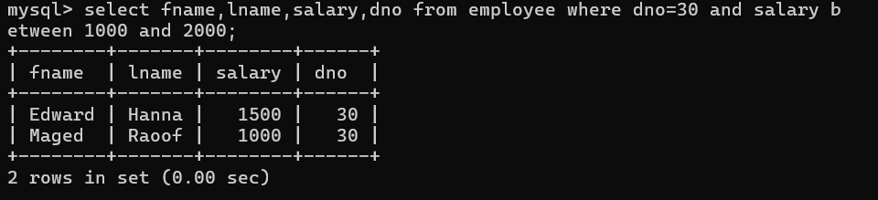

- Display all the projects names, locations and the department number
which is managed by it.
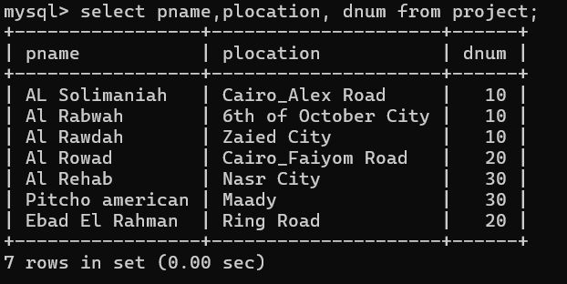

- If you know that the company policy is to pay an annual commission
for each employee which specific percent equals 10% of his/her annual salary .
Display each employee full name
and his annual commission in an ANNUAL COMM column (alias).
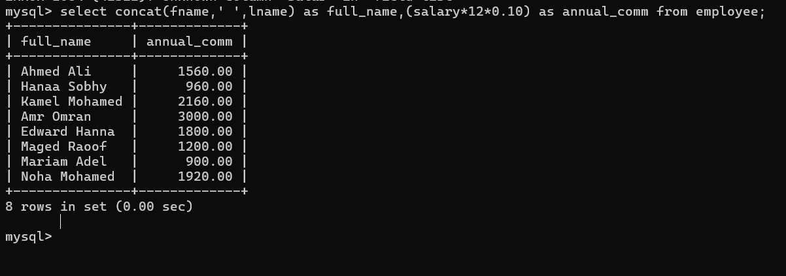

- Display the employees Id, fname who earns more than 10000 LE annually.
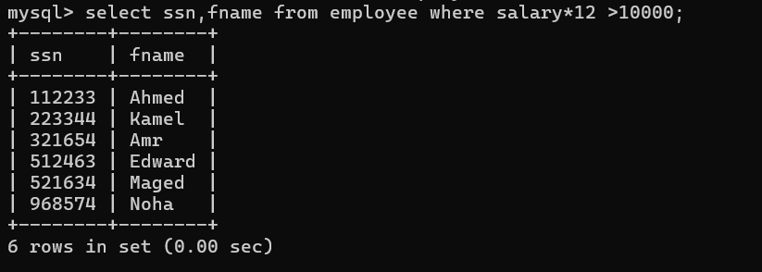

- Display the names and salaries of the female employees
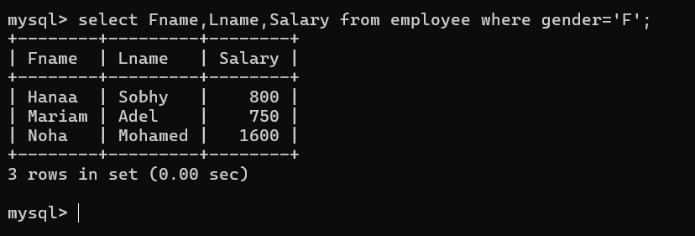

- Display each department id, name which managed
by a manager with id equals 968574.
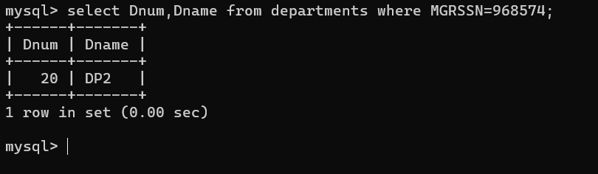

- Display the project id, name and location of the projects which controlled
with department 10 or 20, and location of the projects
in Cairo or Alex city
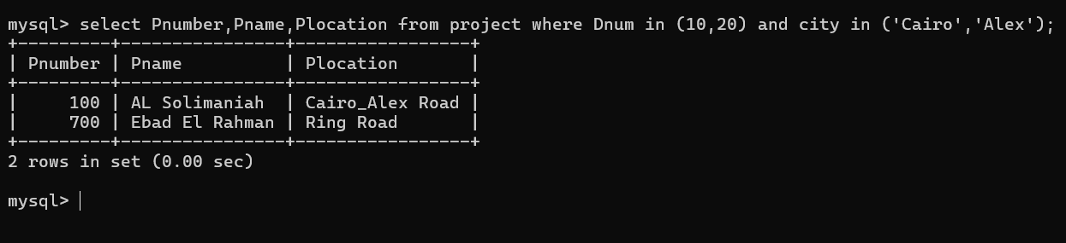

- Display the Projects name, locations of the projects with
a name starts with "a" letter.
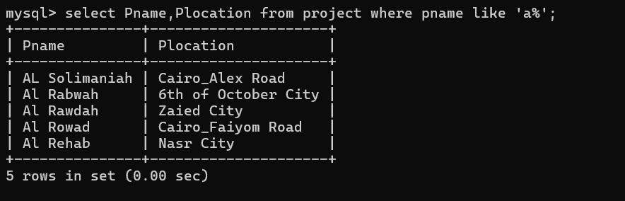

- Display the department number and maximum of salary in each department
Display only departments that has employees,
and has number of employees greater to or equal 2 employees

Data Manipulating Language:
- Insert new employee with your personal data, you will be in
department number 30, your SSN = 666666 , salary = 1000
& Superssn = 112233.

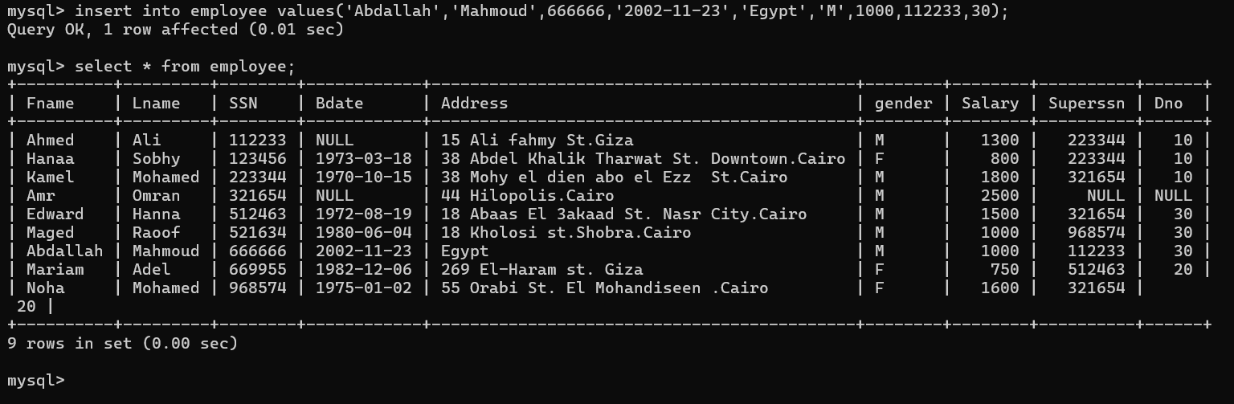

- Insert another employee with personal data your friend
as new employee in department number 30 , SSN = 555555,
but don’t enter any value for salary or supervisor number of him.
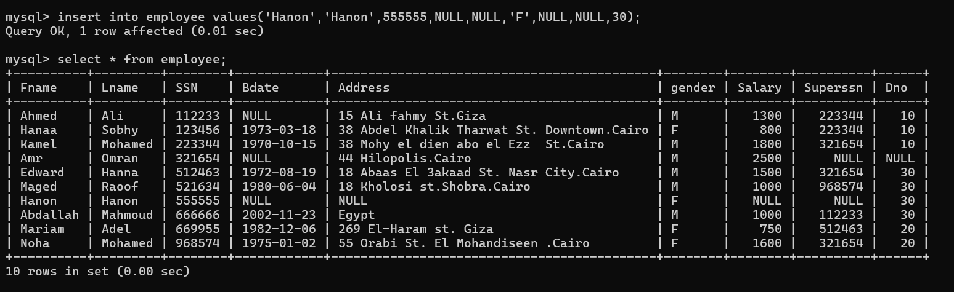

- In the department table insert new department called "DEPT IT",
with id 100, MgrSSN = 112233 as a manager for this department.
The start date for this manager is '1/11/2006'

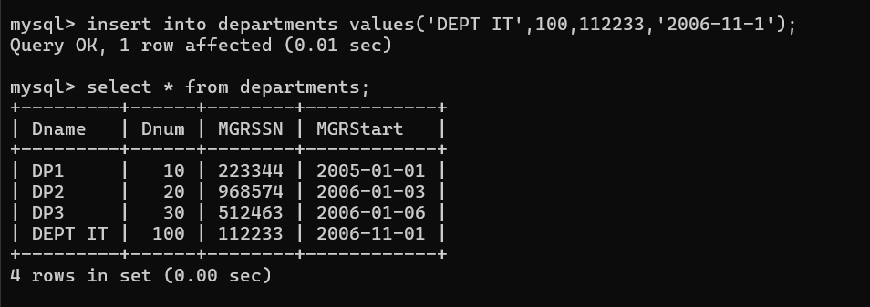

- Do what is required if you know that : Mrs.Noha Mohamed
moved to be the manager of the new department (id = 100),
and they give her position to your friend
Steps:
  - Your friend will be the manager of Dept 20 (her previous department)
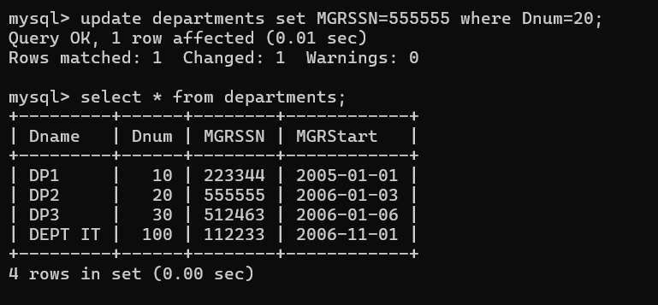

  - Update Noha Mohamed to be the manager of department 100
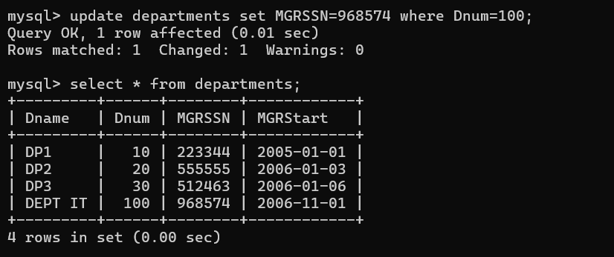

  - Update your friend data, add yourself as a supervisor
for him (supervised by you)
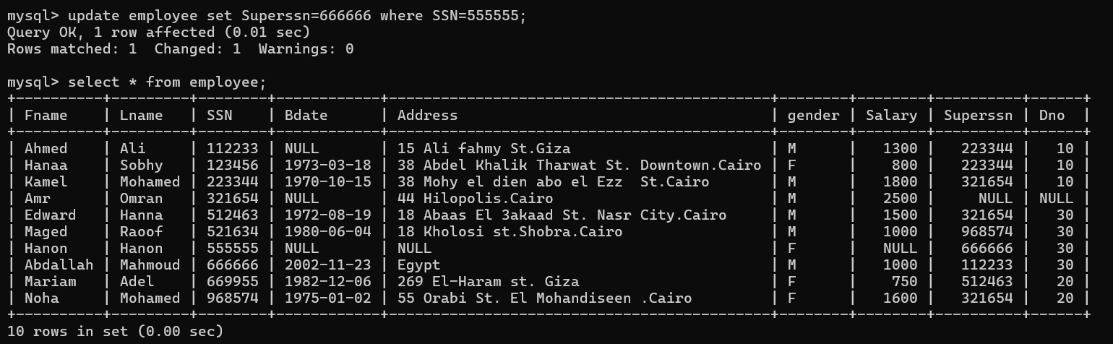

- Unfortunately the company ended the contract with Mr.Kamel Mohamed
so try to delete his data from your database, in case you need,
you can be temporary in his position.
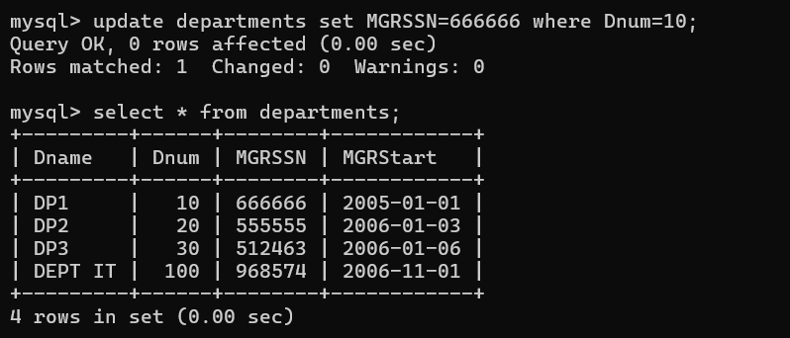
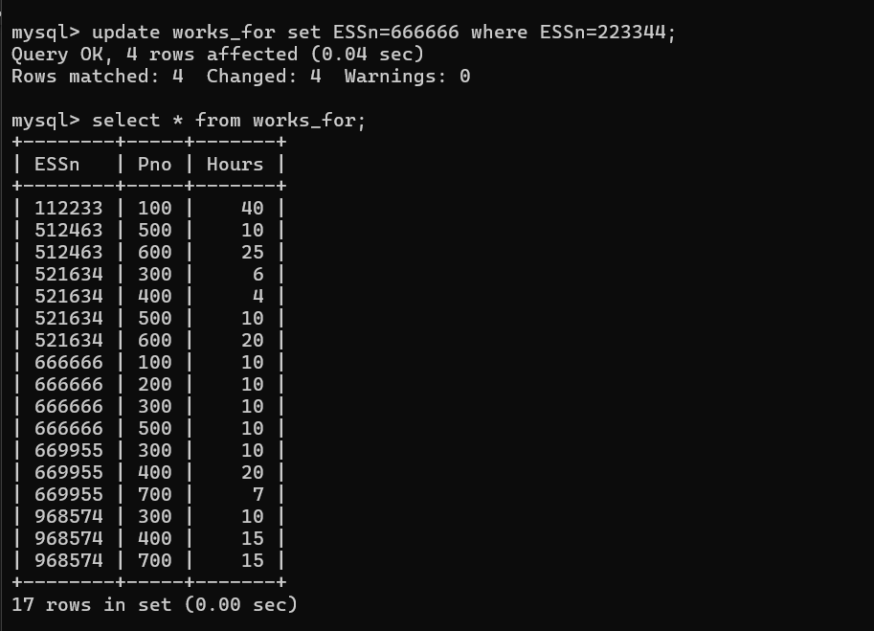

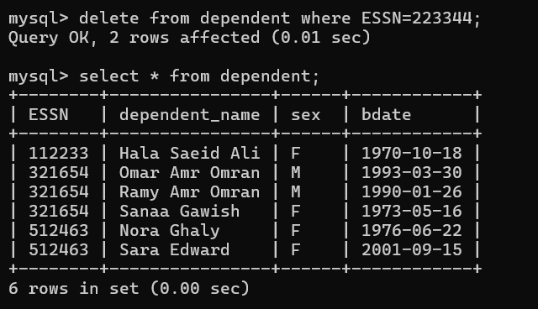
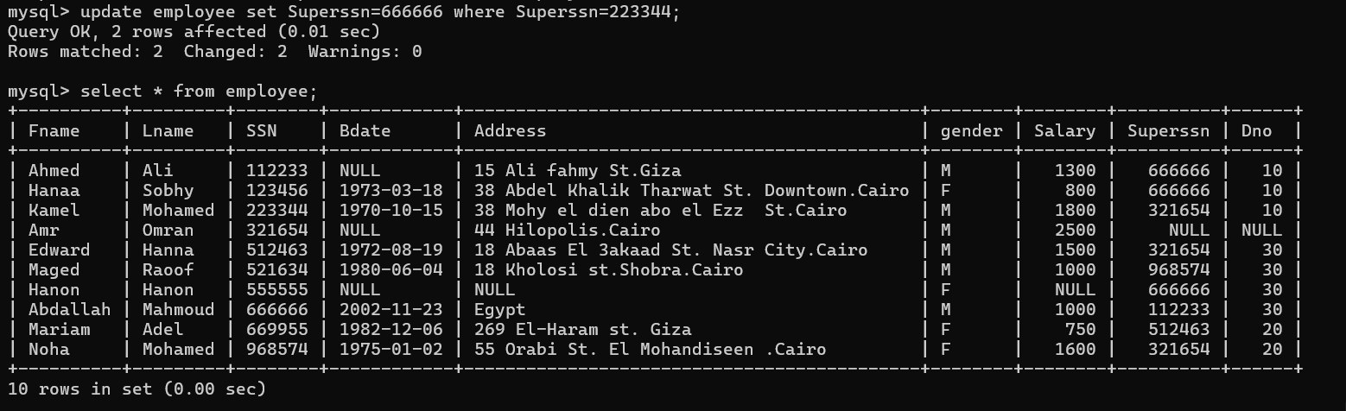
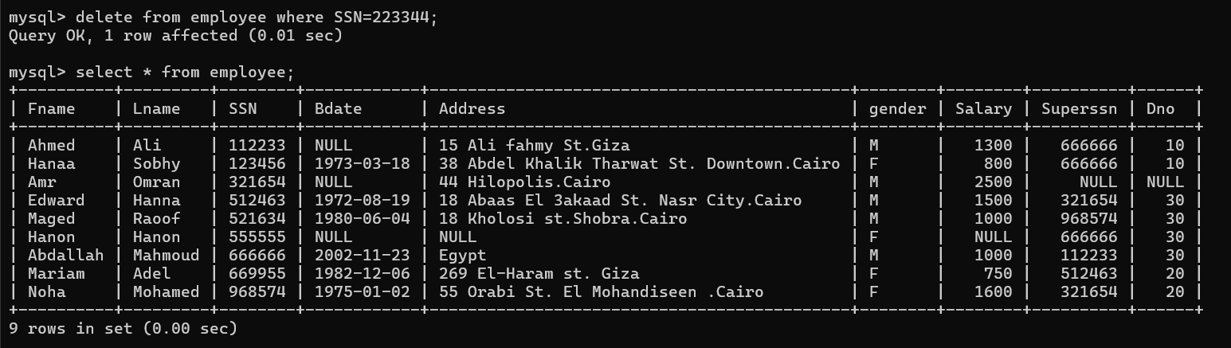

Upgrade your salary by 20 percent of its last value.
